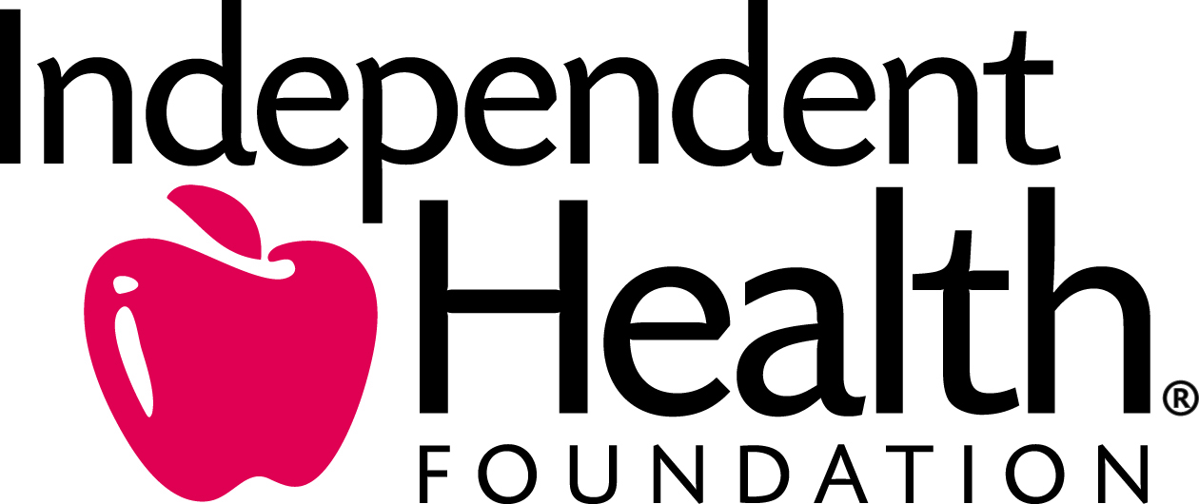

Understanding Food Labels Handout
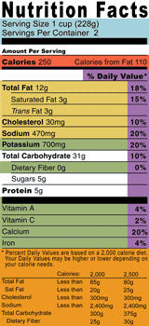

A Quick Guide to Reading the Nutrition Facts Label

- Look here for both the serving size, and the number of servings in the package. Remember to check your portion size to the serving size listed on the label. If the label serving size is one cup, and you eat two cups, you are getting twice the calories, fat and other nutrients listed on the label.

- Check out the total calories and fat. Find out how many calories are in a single serving and the number of calories from fat. It’s smart to cut back on calories and fat if you are watching your weight!

- Let the percent daily values be your guide. Use percent Daily Values (DV) to help you evaluate how a particular food fits into your daily meal plan:

Daily Values are average levels of nutrients for a person eating 2,000 calories a day.

You may need more or less than 2,000 calories per day. The amount of calories you need depends on your weight, height, gender, and activity level.

Look for foods that are lower in calories, fat, saturated fat, and sodium.

Look for foods that are higher in fiber, vitamins, and minerals.

For more information visit www.usda.gov or www.fda.gov.

